Important Facts

1. Each commit creates two objects. 1. Commit Object 2. Tree Object.
2. Version means Commit.   
   Commit mean a reference to a tree.  
   Tree means a set of pointers to blobs and/or directories.
3. Why file name is stored in Tree Object rather than the blob itself?
   1. To reuse the file content in different Git Tree Objects.

17. Section 4 Introduction

1. Git stores four kinds of objects in repo.
   1. BLOB.
   2. Tree.
   3. Commit.
   4. Annotated Text.

PDF - How Git works under the hood

[4. How Git works under the hood (stashchuk.com)](https://stashchuk.com/static/git/4-how-git-works-under-the-hood.pdf)

19. Initialize new Git Repository

1. git init:
   1. To initialize **empty repo** even though directory may be not initialized.
   2. .git hidden folder will be created.
   3. .git is local git repo.
2. ls -la : To display hidden folders.
3. Bash Shell vs Git Bash

|  |  |
| --- | --- |
| Bash Shell | Git Bash |
| Doesn’t show if current dir is under git control. |  |
| Doesn’t show the current branch. |  |

20. Overview of .git folder

1. Command: start . or explorer .
2. under .git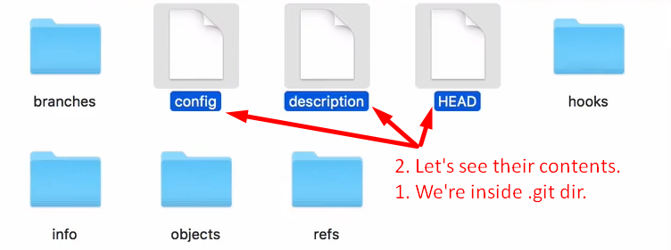  
   above, git has its own **file system**.  
   Objects directory stores git objects (BLOB, Tree, Commit, Annotated Text)

21. Git object Types

1. Those four objects are used to track files and changes in the files.
   * 1. **Blob**: Any kind of file is stored as blob.
     2. **Tree**: To store directory info. Dir maybe empty or contain other files and/or directories.
        1. Tree is set of blobs (files) and/or other trees (dirs)
     3. **Commit**: This object is used to store different versions of our project.
     4. **Annotated Tag:** Text pointer to other commits.
2. Low level commands:
   1. **git hash-object**: To create git object only BLOB.
   2. **git cat-file**: To read git object.

22. Writing new git object with hash-object.

1. 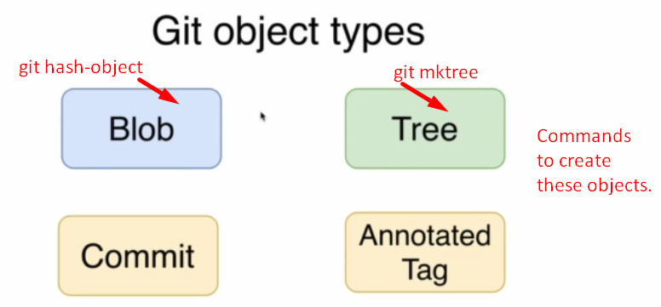
2. 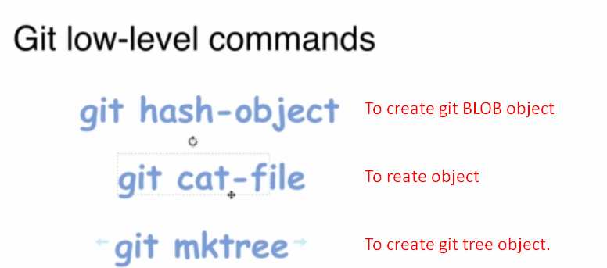
3. d

|  |  |  |  |  |  |
| --- | --- | --- | --- | --- | --- |
| Linux Command | input: All formats allowed |  | git command | Input source | To save object under .git/objects |
| echo | “Hello, Git” | | | git hash-object | --stdio | -w |
|  | ‘Hello, Git’ |  |  |  |  |
|  | Hello, Git |  |  |  |  |

Let’s assume the hash for the BLOB 🡺 **b7**aec520dec0a7516c18eb4c68b64ae1eb9b5a5e  
output: 

hash = Folder Name + File Name.

23. JSON vs Git database

1. Git DB Structure similar to JSON.
   1. **Key**: The hash of the file.
   2. **Value**: The file itself.  
      But in Git, even can not be duplicated as key is calculated based on file’s content.   
      If file content is same then same key will be achieved.
2. Hash = Folder Name + File Name.

24. What is hash function

1. We know that based on file’s content, hash code is generated and then the generated blob is stored under .git/objects creating a new folder whose name is first 2 characters of the hash code and blob is stored inside this folder and its name is the remaining hash characters.  
   file content 🡪 hash-function() 🡪 BLOB 🡪 Folder
2. Always Fixed Length Hash.
3. Hash functions are “One-Way” function.
4. Same hash function will create same hash code for the same input.

25. Hash functions overview

1. 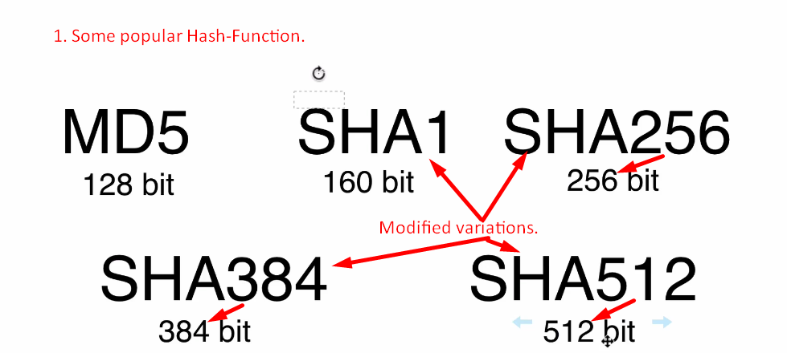
2. Variable Length input but Fixed length Hash.

25. SHA1 Hash Function

1. SHA1: 160Bit = 40 Hexadecimal Characters, hash Function or algo.
2. **Commands**: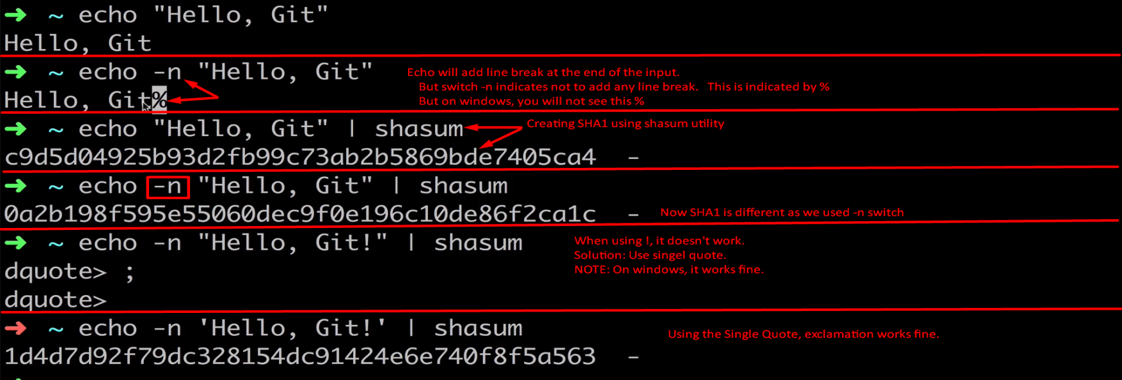

26. How many files Git can store

1. 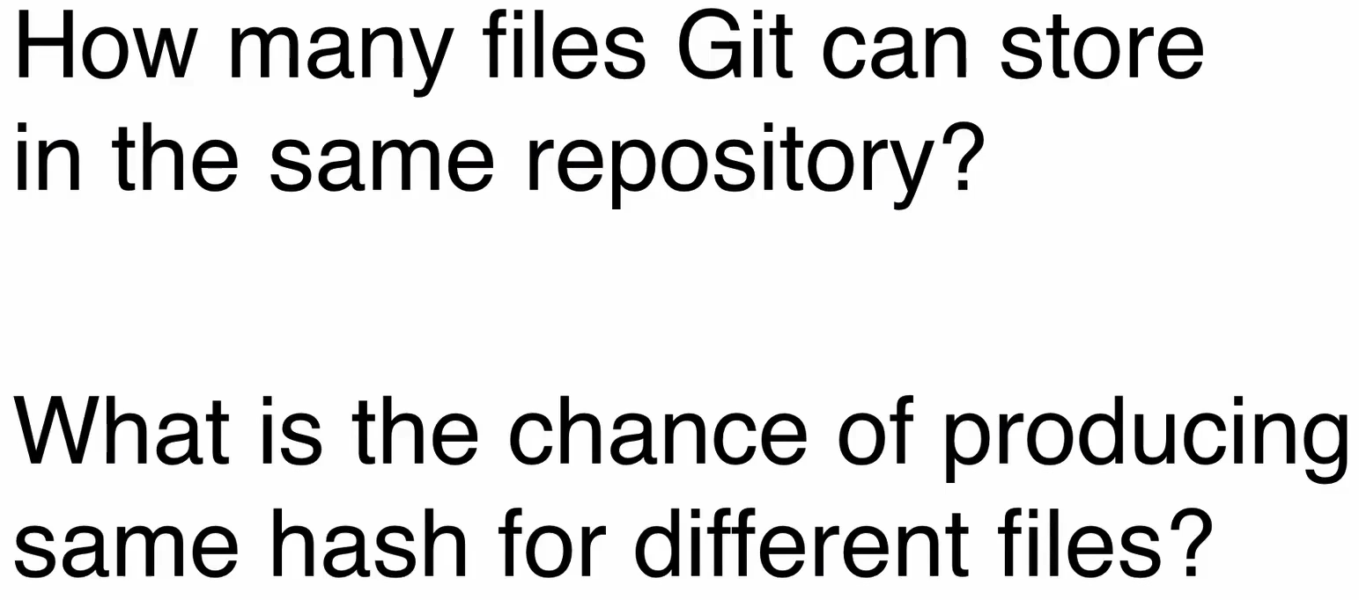  
   Same hash for different file which is called **Hash Collision**.
2. Git uses SHA1 (160bit) hash function. So 2^160 different **hash codes** after that collision.

27. Probability Theory In Dice Game

1. 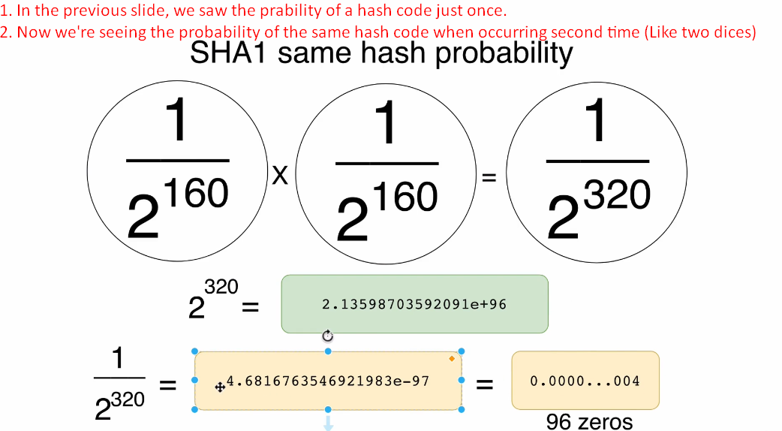

28. Git Hash Collision Prabability

1. 

32. Exploring git objects with git cat-file commands

1. 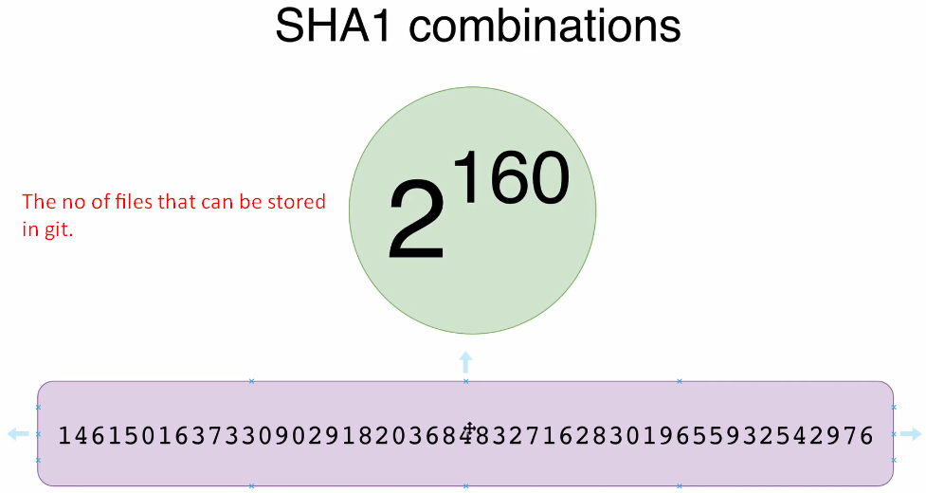As git uses JSON similar format => Key, Value Pair where key is hash of the file and we can create 2^160 combinations so that many files can be stored in Git DB/Repo.
2. **Commands**:  
   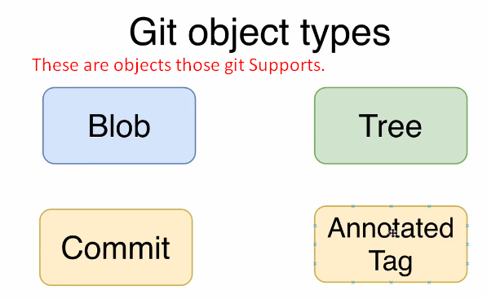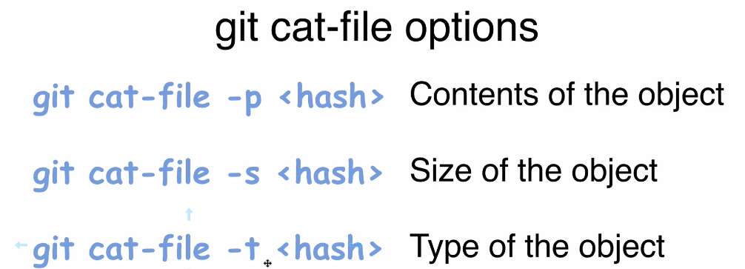
3. git cat-file -p <hash> Seeing the content of a blob.  
   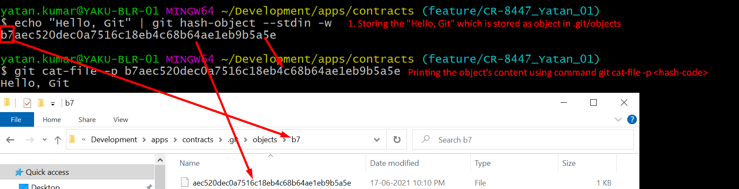
4. git cat-file -t <hash>  
   
5. git cat-file -s <hash>  
   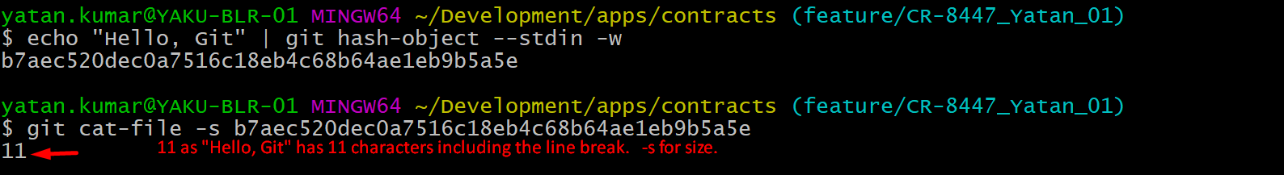

33. Create new Git Blob based on a file

1. 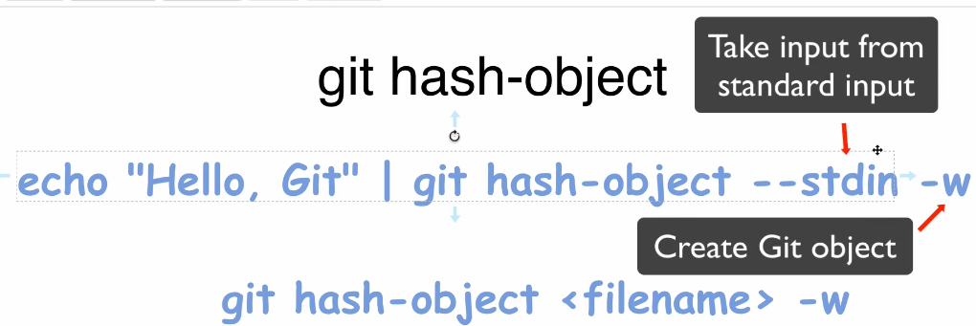
2. hash-object calculates hashcode based on input, type, size whereas shasum uses only input. So hashcodes are different by both even though same input file and input, type, size are stored in blob itself.

35. Contents of Git Objects

1. 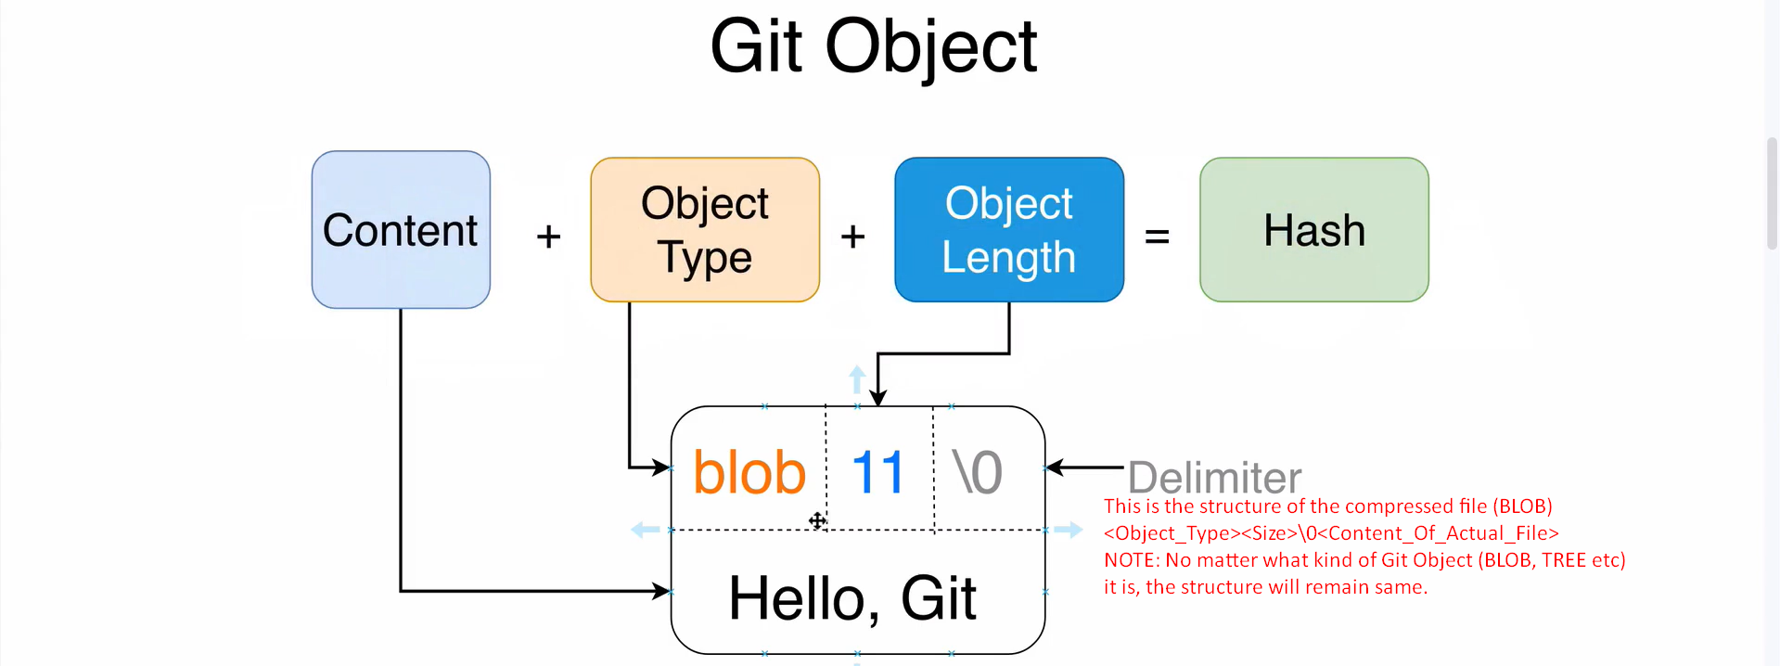

36. What we have so far

37. Tree Objects in Git

1. 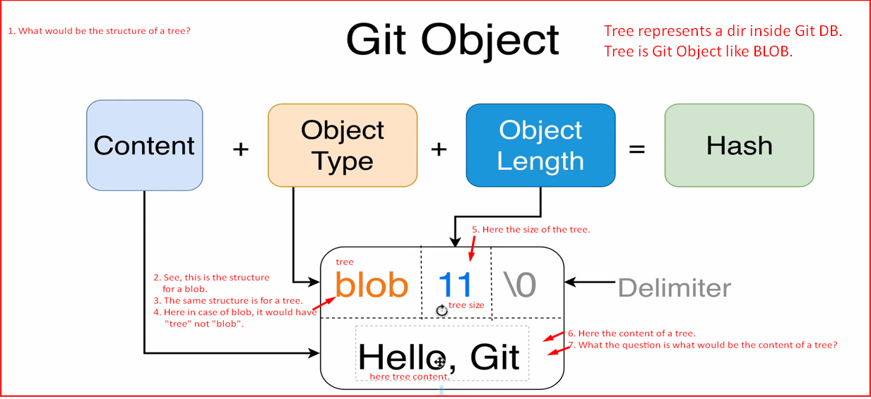
2. 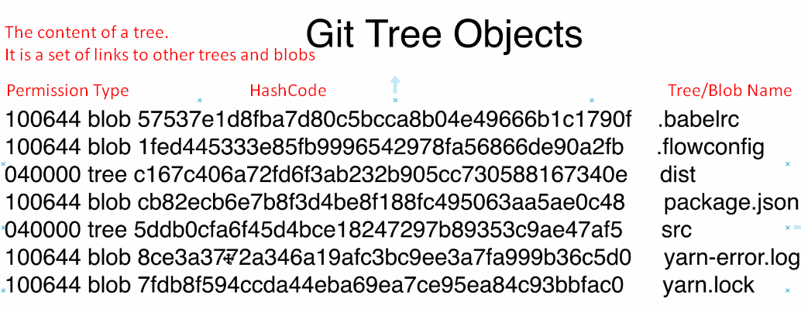
   1. Tree contains a set of links to other Git Objects under it.
   2. **Every line has 4 fields.**
      1. Permission.
      2. Type of the Git Object.
      3. SHA1 HashCode.
      4. The file/Directory name (This is where file name is stored in tree object not in the blob object as we discussed in the previous lecture that blob doesn’t contain file name).

38. Git Object Permission

1. 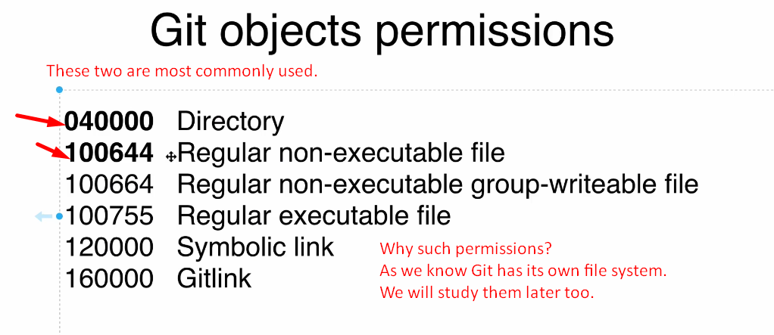
2. 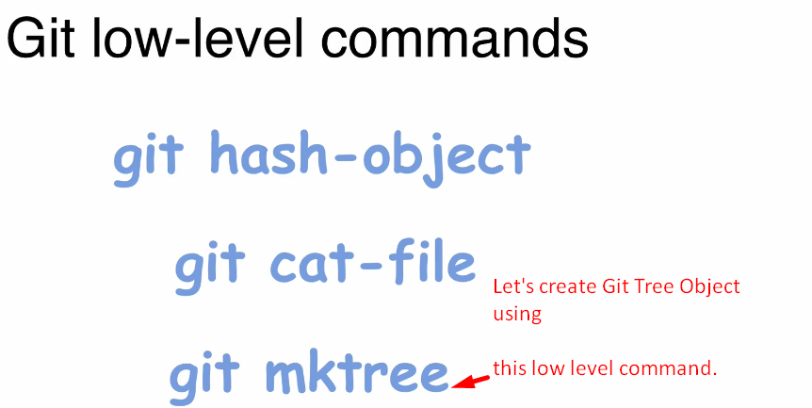

39. Creating Git Tree Object

1. 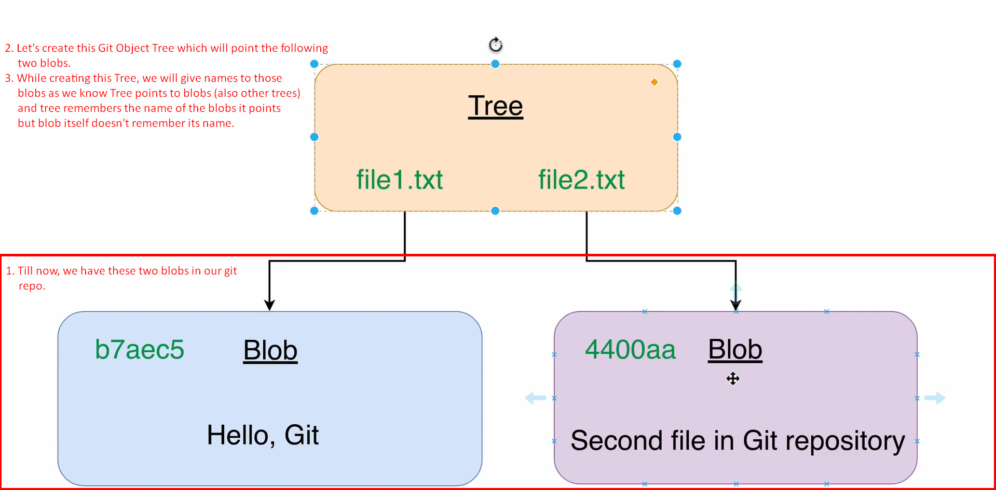
2. 
3. 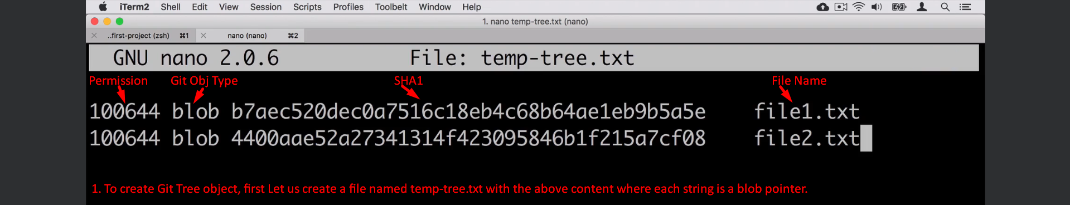
4. 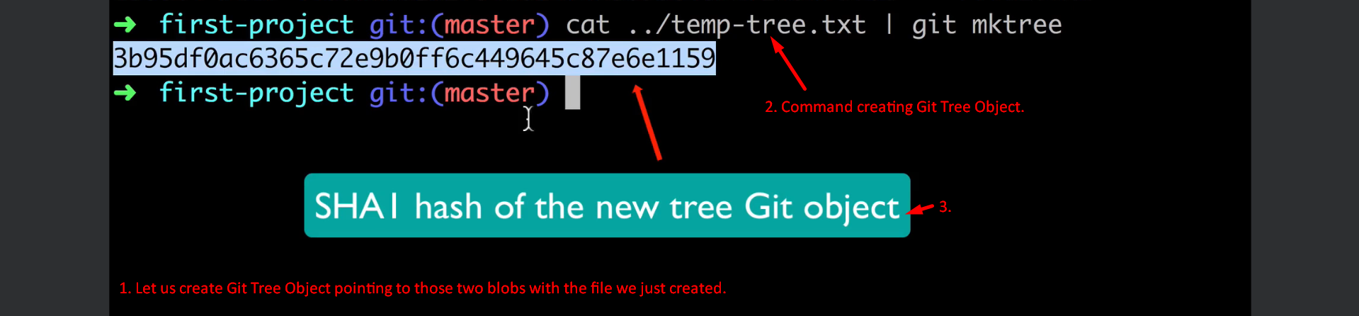
5. **Just Linux Command Info**:  
   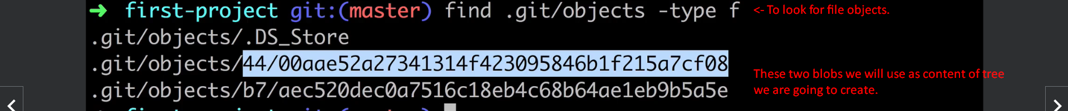

40. Examining Tree Object

1. Following SHA1 is SHA1 of the Git Tree Object Let us apply the following commands on the Git Tree Object.
2. git cat-file -p <sha1> 🡺 To see the content of a Git Object here Tree.  
   
3. git cat-file -s <sha1> 🡺 To see the size of Git Object here Tree.  
   
4. git cat-file -t <sha1> 🡺 To see the type of the Git Object.  
   

41. Working directory, Staging area and Git Repository

1. 
2. 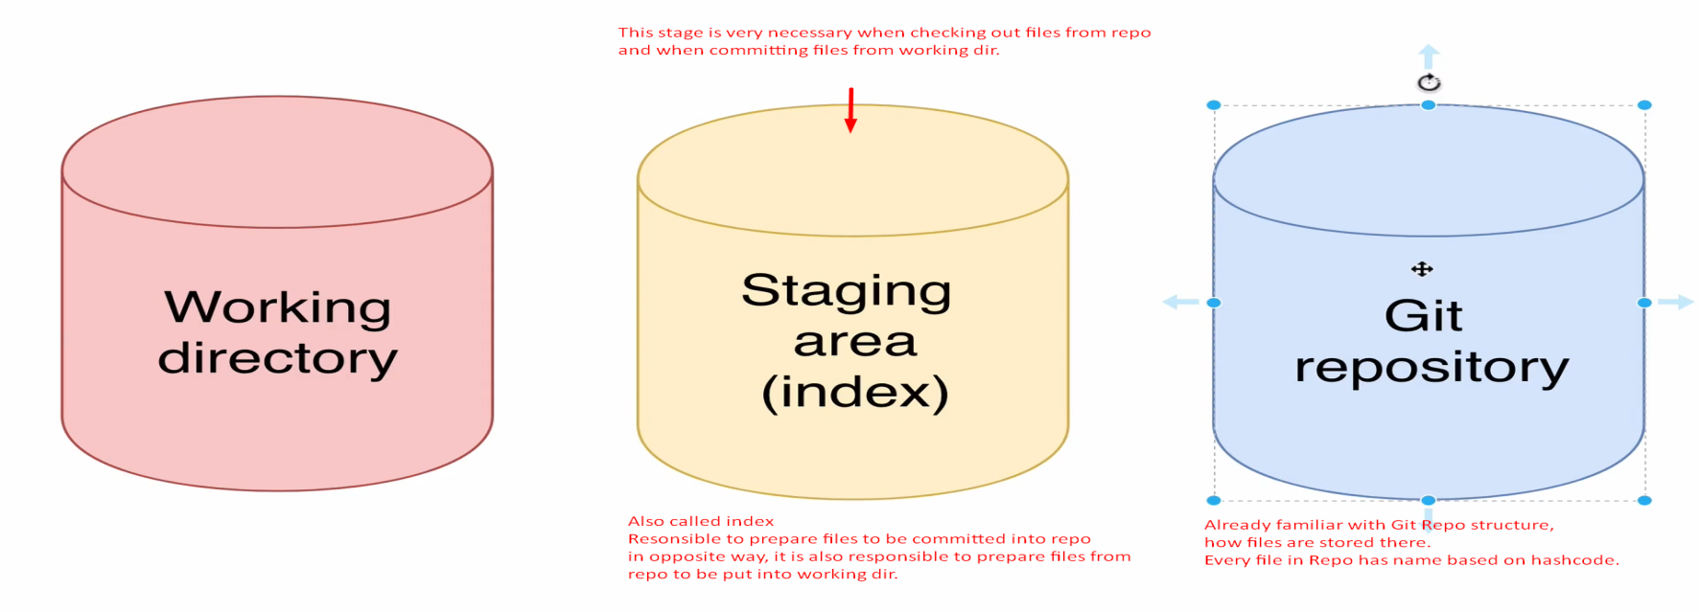
3. **Terms**: Working Directory, Staging Area (also called index), Git Repository.

43. Git read-tree

1. 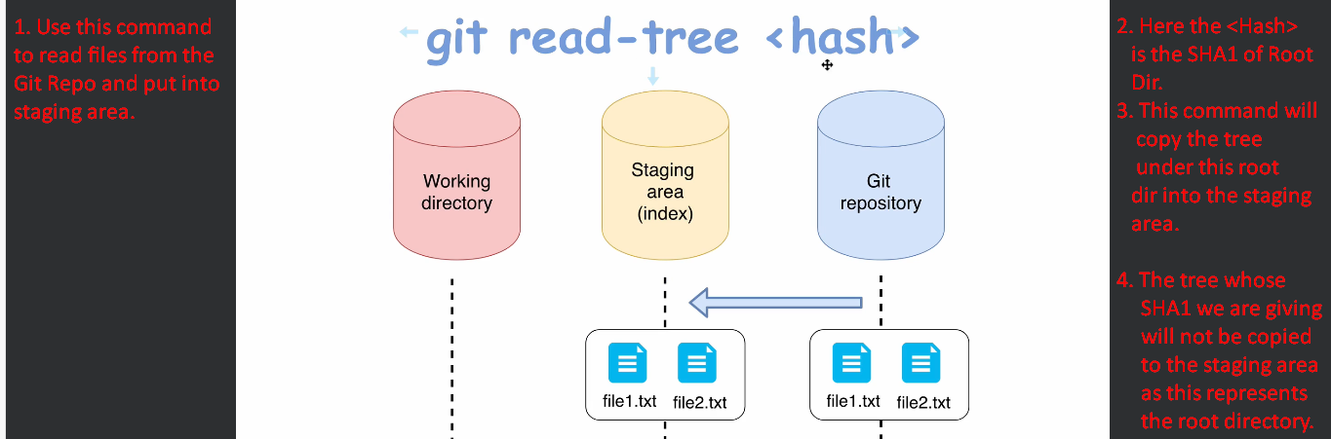

44. Read files in the Staging-Area Using git ls-files

1. 
2.   
   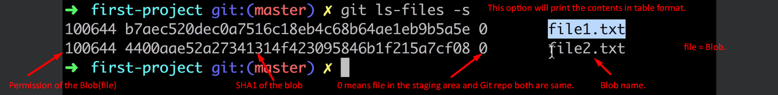

45. Git Checkout Index.

1. 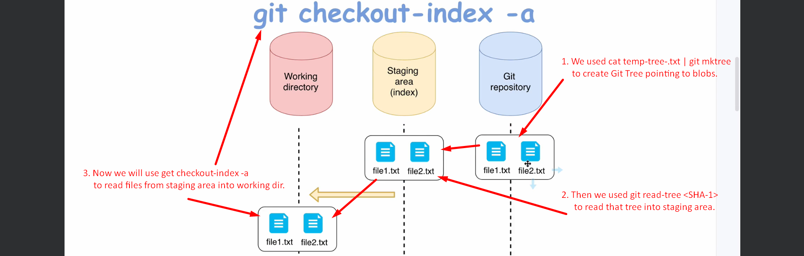

46. How many Folders Can Be Created for Objects

1. 

48. Section 5 Introduction

49. Pdf Basic Git Operation

50. What is a commit

1. Git Object. So, it has its own SHA1. Used to store different versions/snapshots.  
   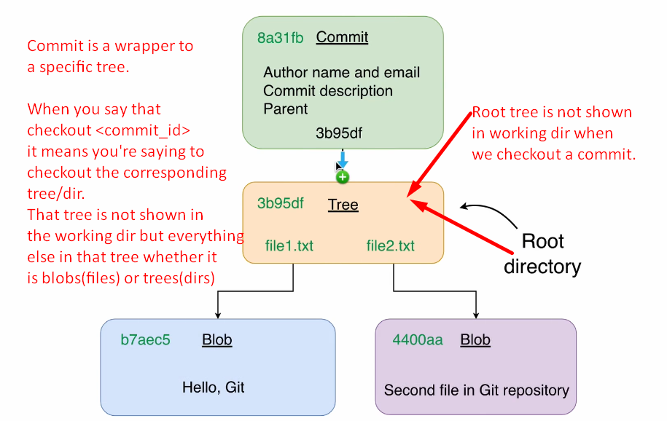  
   

51. Configure Git Author Name and Email

1. Username and email can be set globally and per project.
2. **Command**:  
   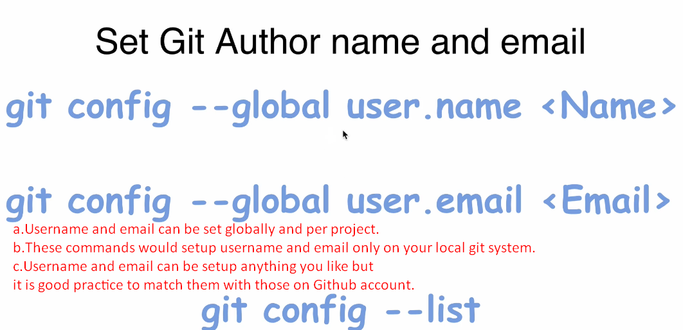

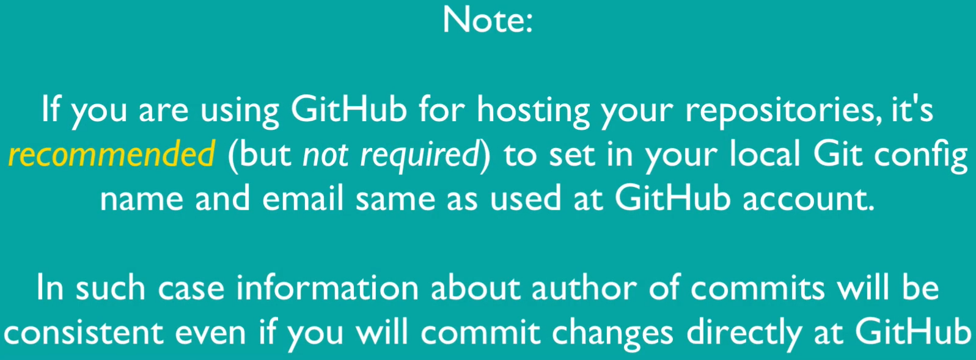

52. Creating first Commit

1. **Always Remember**: Commit always points to Root Tree.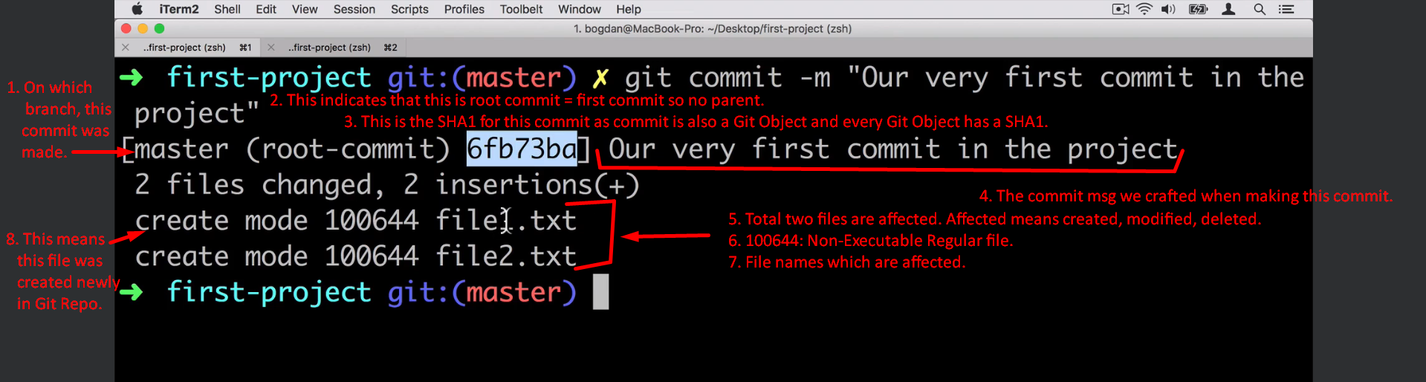

53. Exploring Git Object

1. Git commit object is a wrapper around Root Tree (which is a Git Object again).  
   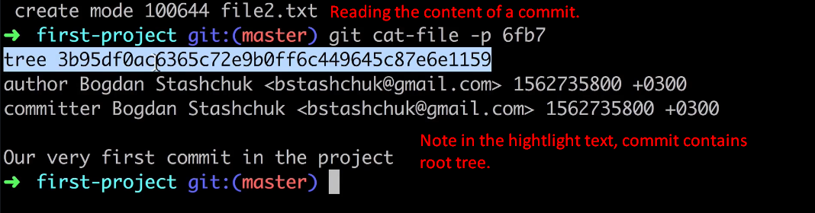

54. Current State Overview

1. 

55. Basic Git Commands

1. 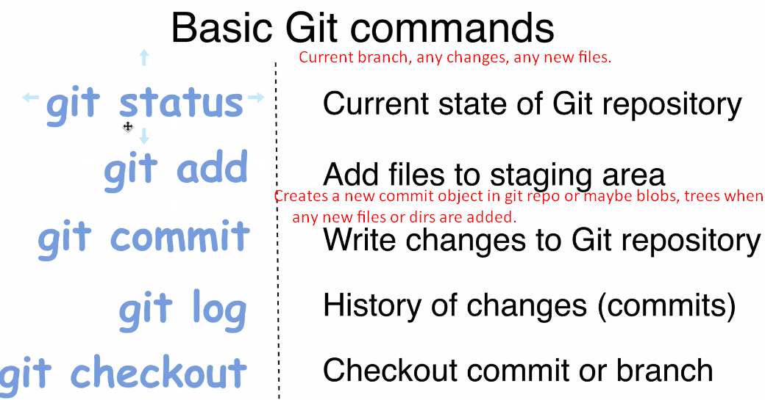
2. 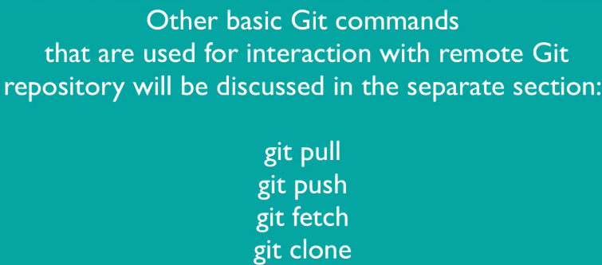

56. Adding new file to working directory

1. We added a new file in the Working Directory.   
   Then doing this 🡪   
   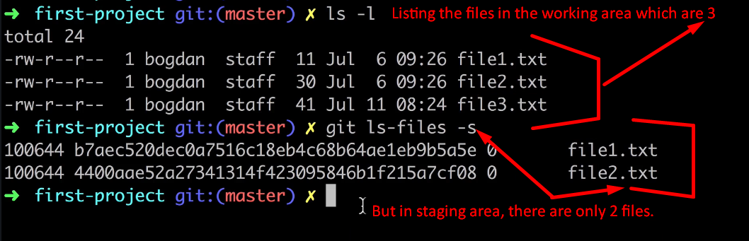

57. Git files lifecycle

1. 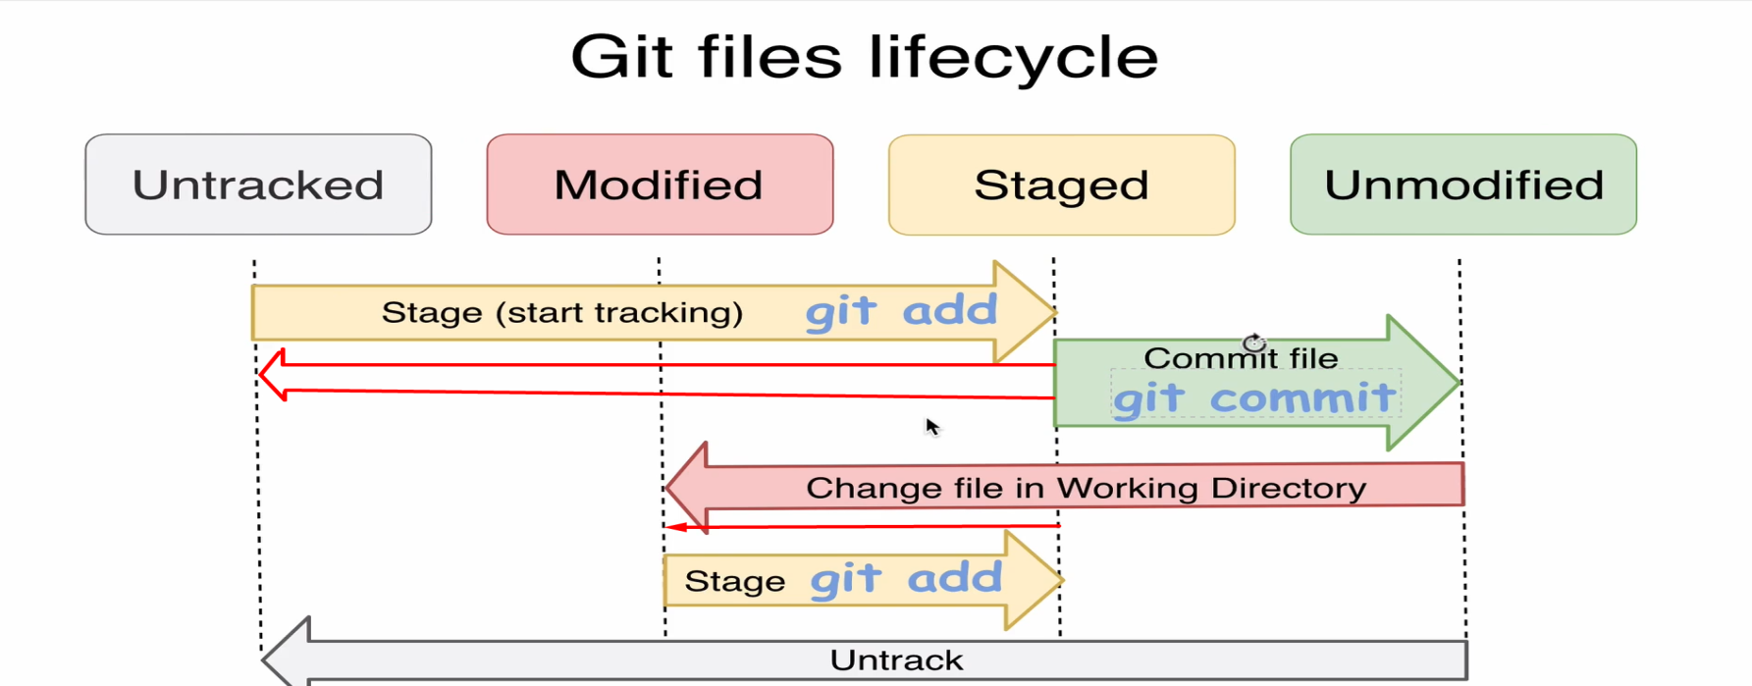

58. Stage File

59. Unstaging a file using git rm

1. Working Tree is different than Working Directory.
2. git rm --cache file3.txt
   1. This command will the file from the working tree as well as from the staging area but not from the directory. See the following side.  
      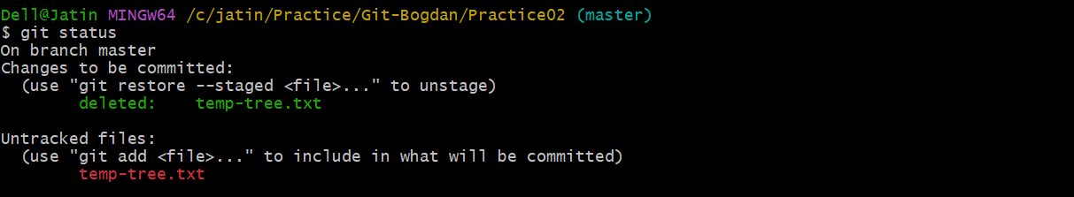  
      See when a file is in untracked state, it is not part of the working tree but yes it is still part of the working directory as you can see in the above slide the file has been removed from the staging area and working tree.   
      If a file is removed from the staging area, it means there is a change in the index and so a commit is ready to be made.

60. Commit Changes

1. 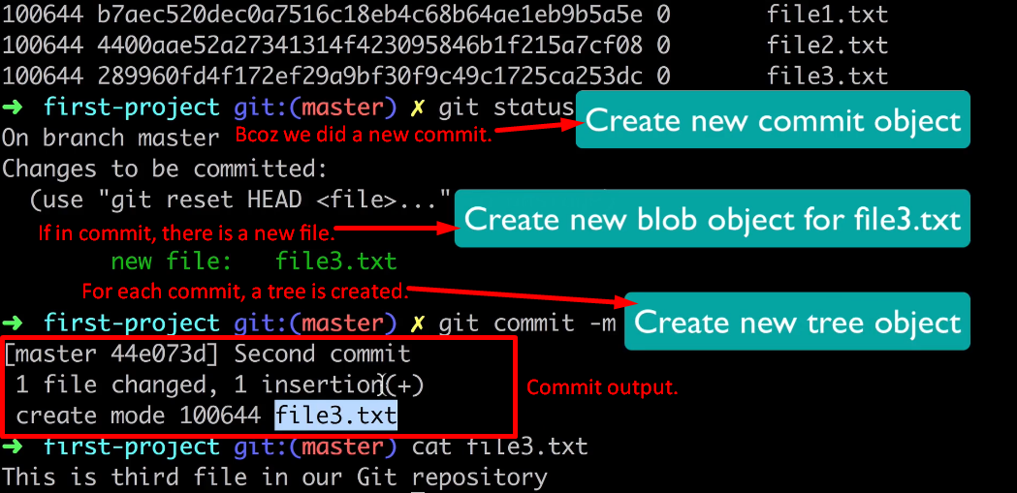

61. Exploring changes in Git Repository

1. 
2. 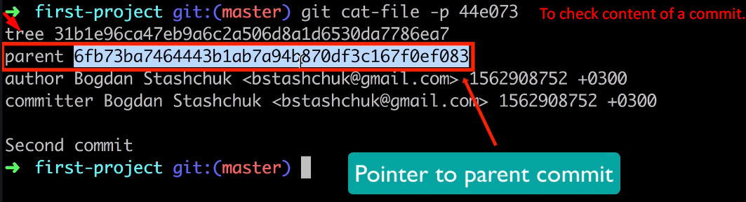  
   Let’s explore the parent commit.  
   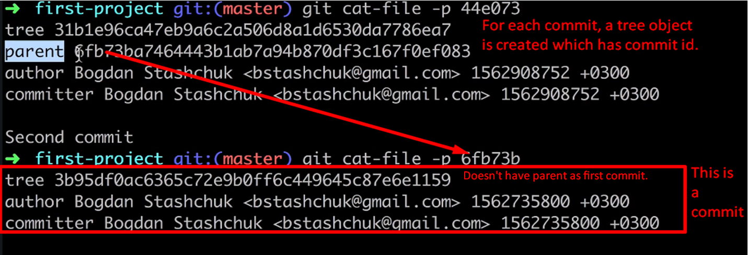

61. Exploring changes in Git Repository

1. 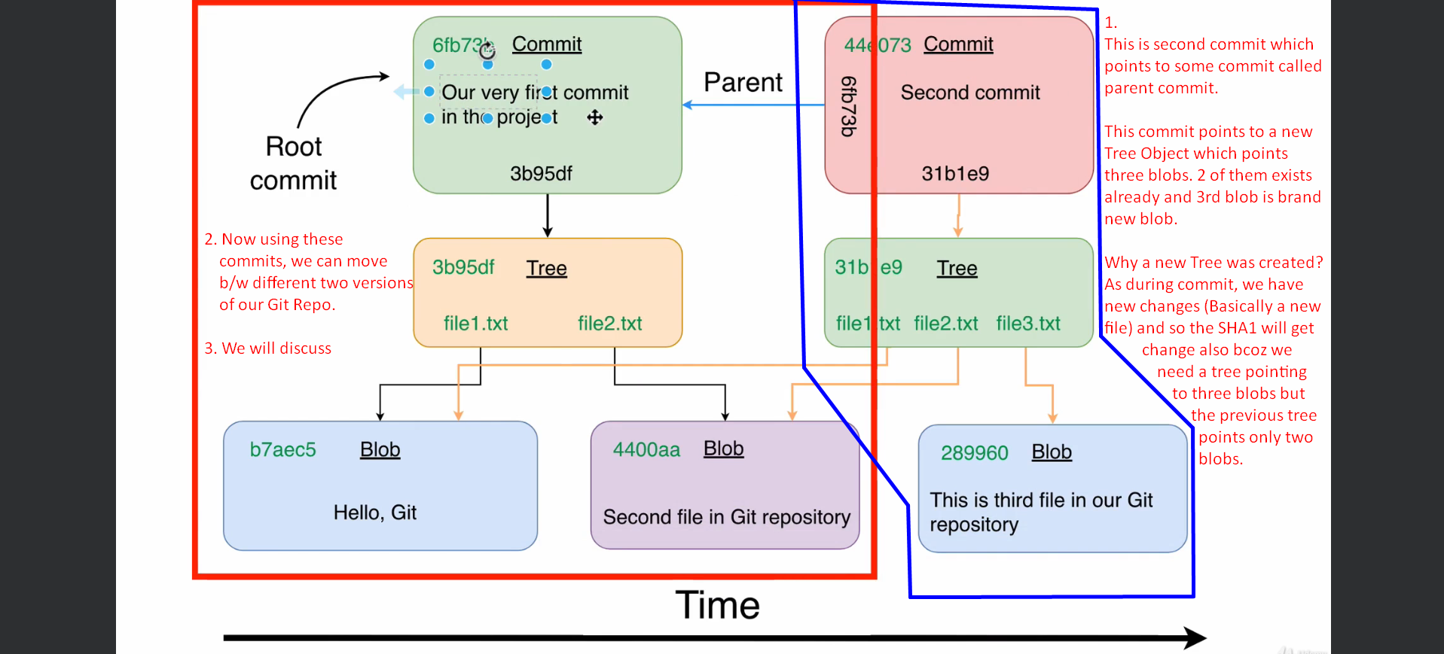

63. Section 6 Introduction

65. Most common Git Operations

1. git checkout:
   1. Used to checkout a particular commit/version. As we know each commit is a wrapper around a root tree so all the files and folders which are being referenced by that root tree will be put in the working tree as well as staging area.
2. 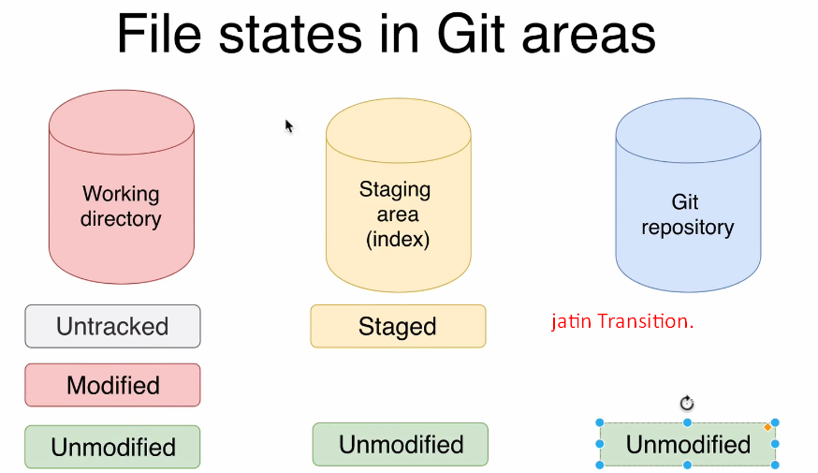   
   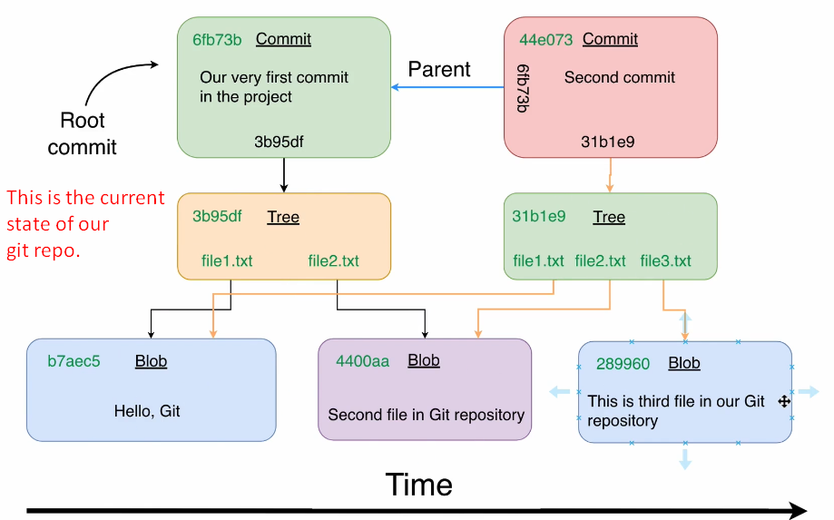
3. Following options to fetch a Git Repo into Github Desktop.

69, What is branch in Git

1. 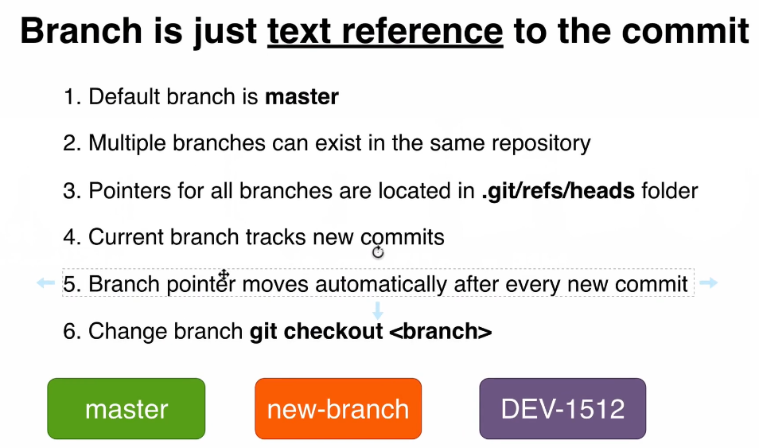
2. A branch contains always the last commit.

70. What is HEAD in Git

1. How does Git know which branch is current branch?
2. 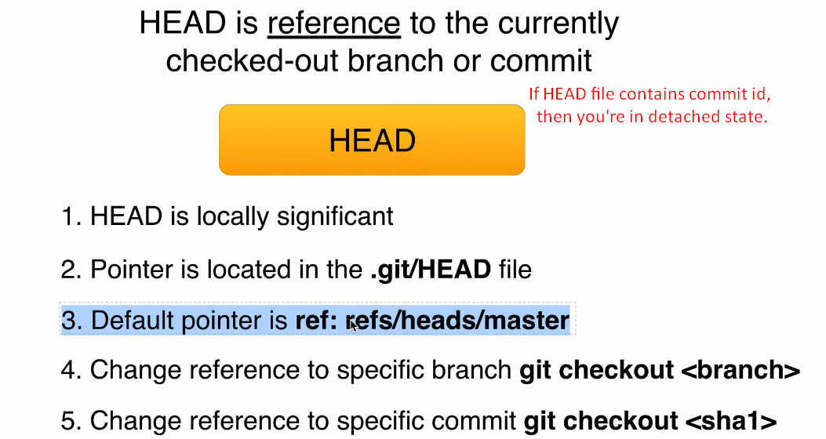
3. 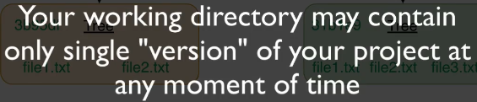
4. 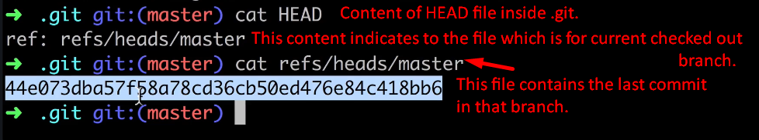
5. 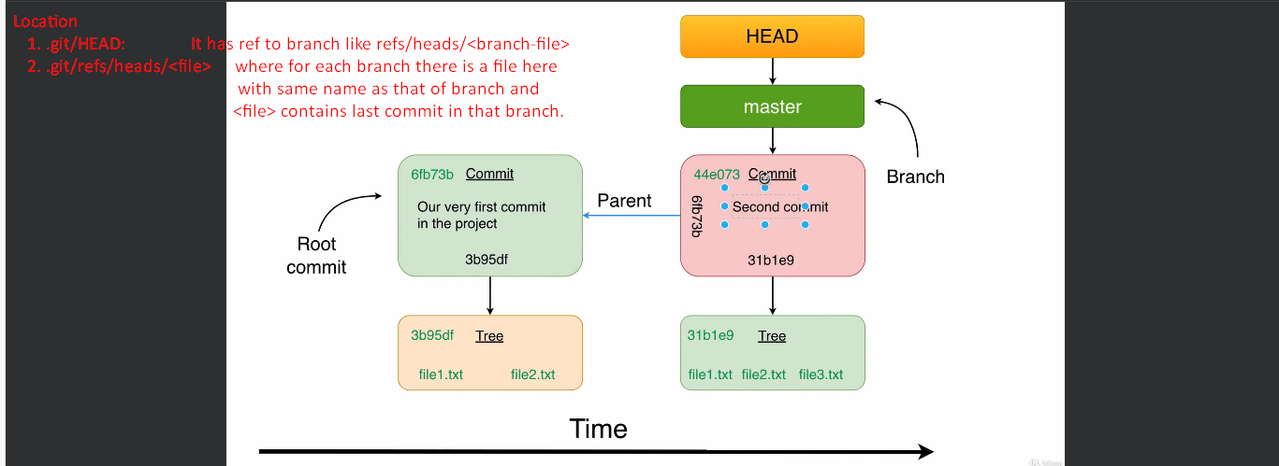
6. 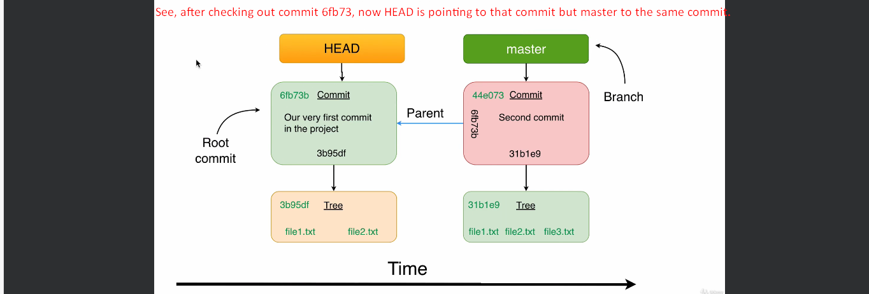

71. Third Commit

1. 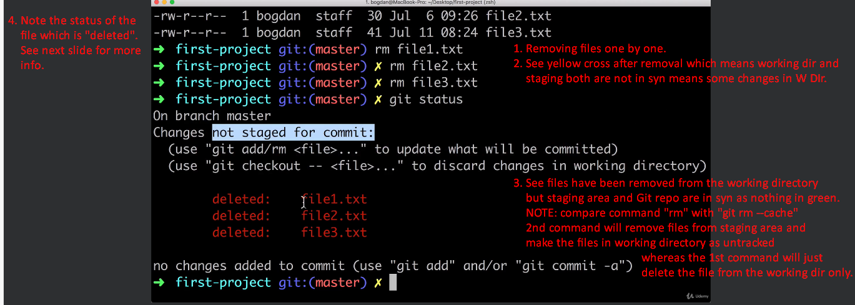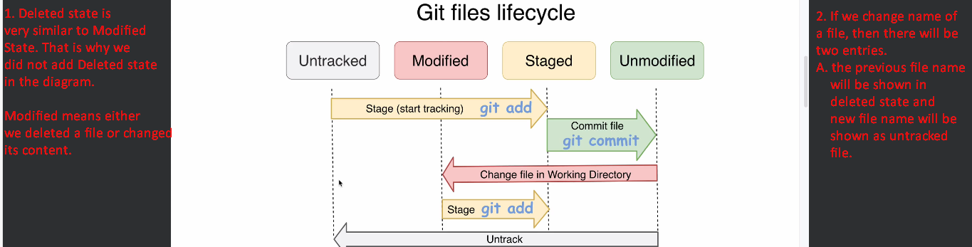

72. Git Repo Changes after Third Commit

1. 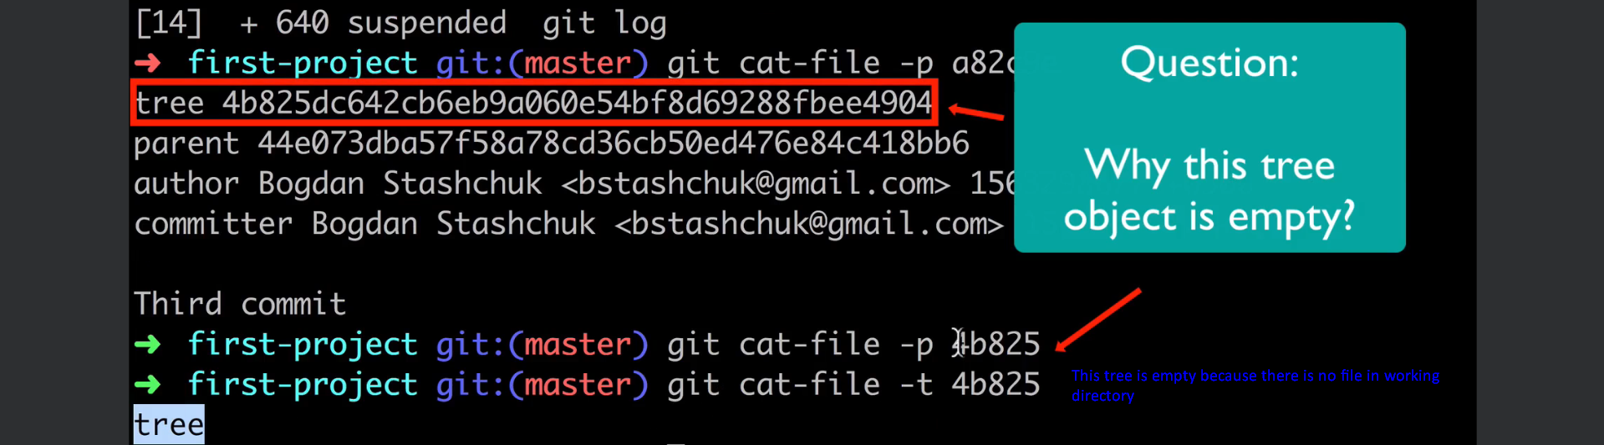
2. 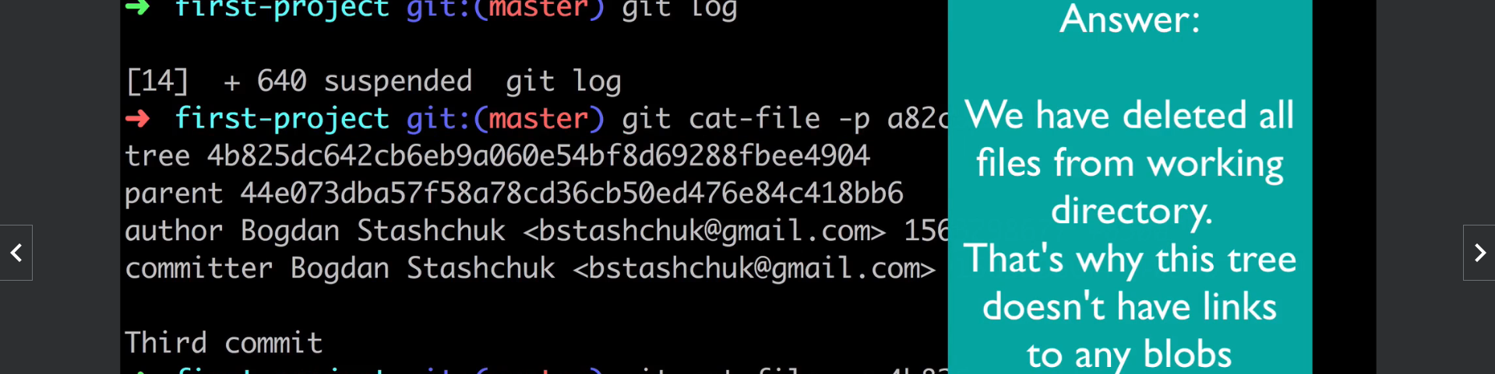  
   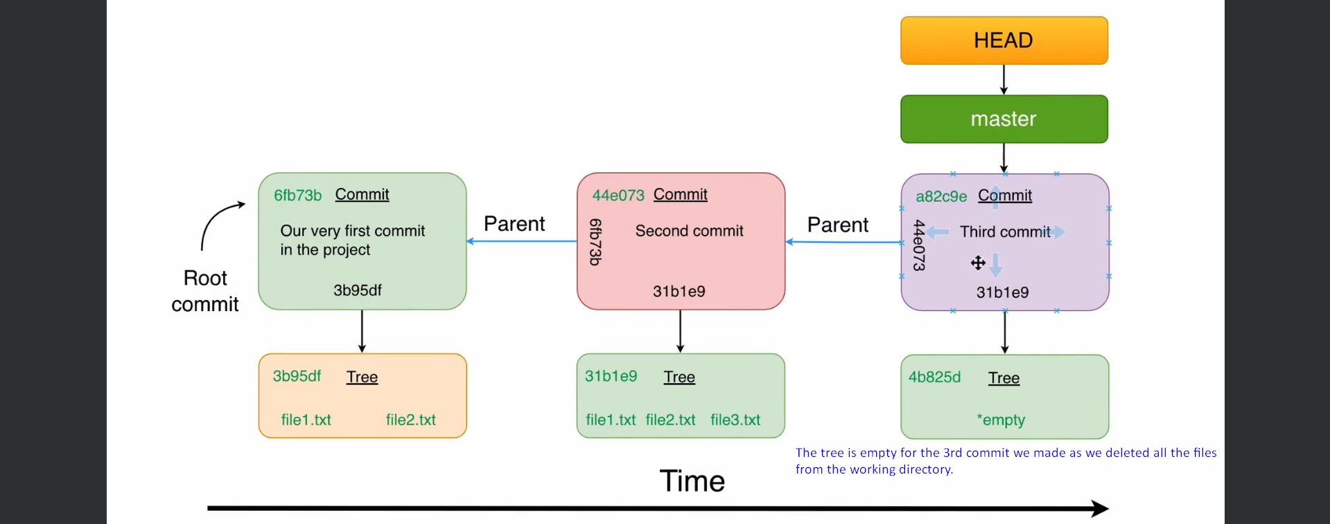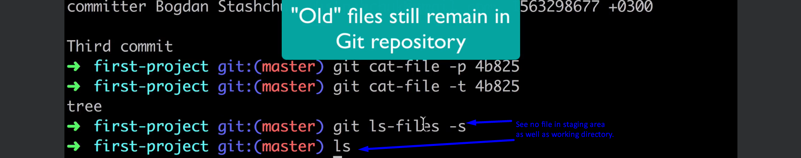

73. Checkout a Specific Commit

1. 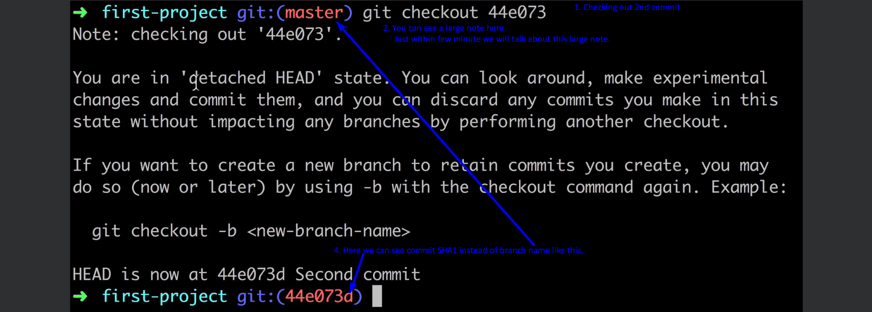
2. 

74. Why do we need branch

1. **About Branch**:
   1. Every branch is a separate story of our project.
   2. Commits can be made in different branches in parallel.
   3. Branches greatly simplify the collaboration process.
   4. Branch is simply a text for a commit and so human-readable and next time, it is easy to checkout that commit.

75. Git Branches Management

1. 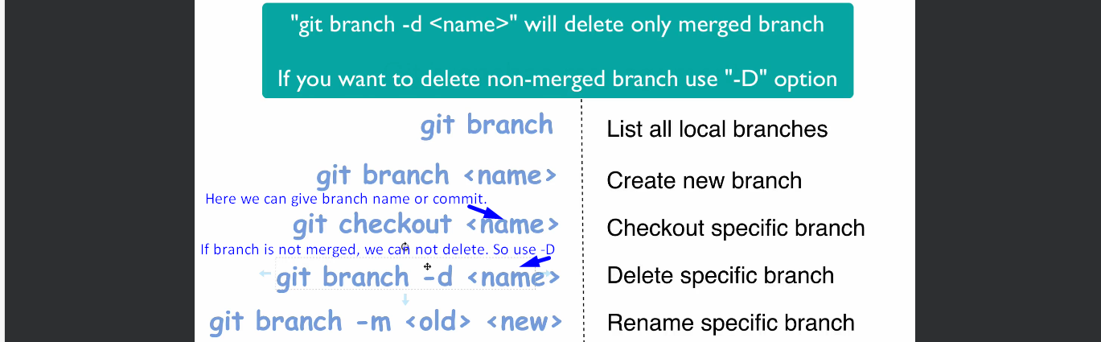

76. Create new branch

1. 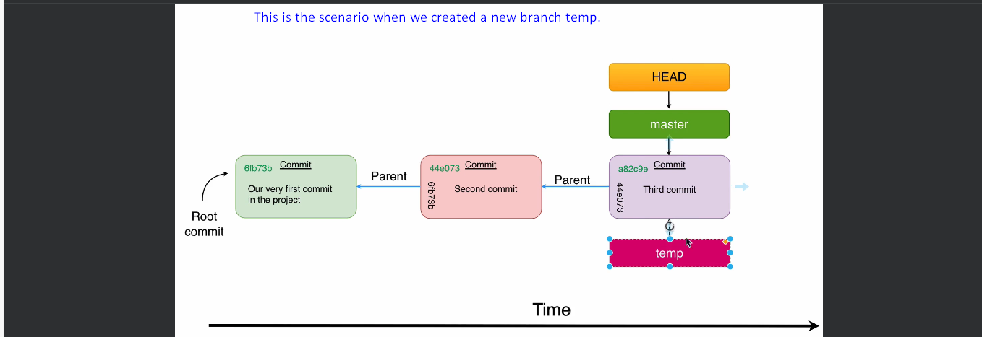

77. Commit Changes in the new branch

1. 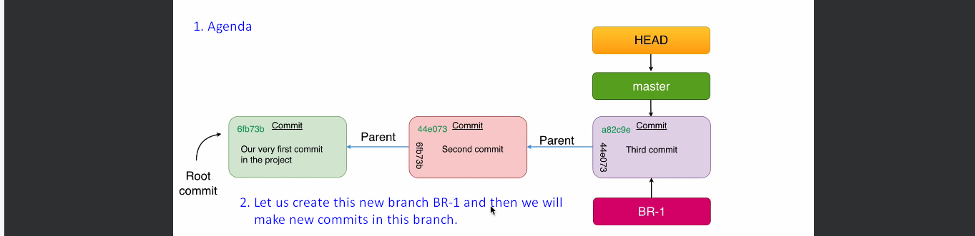
2. 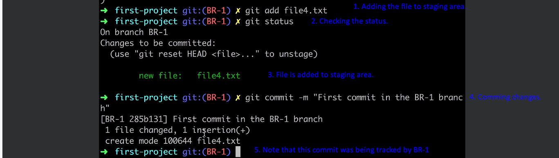

78. Explore Commit in the new Branch

1. 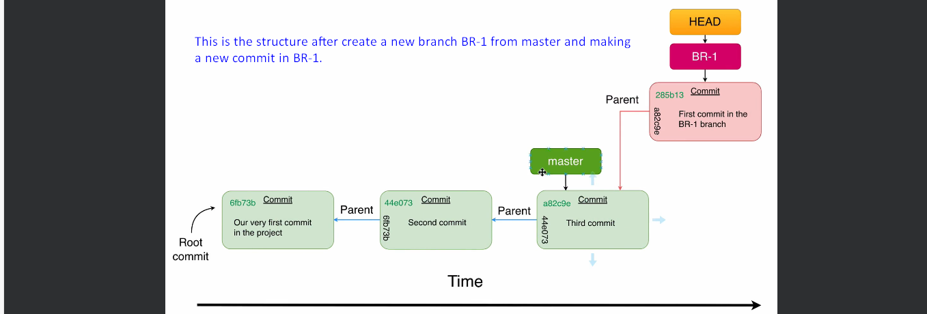

79. Git Reuses Blobs with the same contents

1. 